INTRODUCTION
Looking for an online comprehensive solution to manage internet banking. This will be accessible to all customers who have a valid user id and password. This system provides the following facilities………
- Balance enquiry
- Funds transfer to another account in the same bank
- Request for cheque book/change of address/stop payment of cheques.
- Viewing monthly and annual statements
In India, a number of banks have either gone for Internet Banking or are on the verge of going for it. Internet Banking System I am talking about is different from what was possible up to now - off line information or few limited services. I am talking about the type that enables the customer to transact business on line in real time.
The Internet Banking System provides the facilities like Balance Enquiry , Funds transfer to another account in the same bank, Request for cheque book /change of address/stop payment of cheques and Viewing monthly and annual statements. The Internet Banking System has developed a new security infrastructure for conducting commerce on the Internet. The initiative, called BankID, aims to become a national ID infrastructure supporting services such as authentication and digital signatures for the entire authentication population.
Many researchers expect rapid growth in customers using online banking products and services. The Internet Banking System allows customer contact through increased geographical reach and lower cost delivery channels. Customers can reach a given institution from literally anywhere in the world. Management must understand the risks associated with The Internet Banking System before they make a decision to develop a particular class of business. Management should have the skills to effectively evaluate internet banking technologies and products. Use the Internet Banking System, the choice is yours. Make it wisely.

DATA FLOW DIAGRAMS

DATA FLOW DIAGRAMS:
A graphical tool used to describe and analyze the moment of data through a system manual or automated including the process, stores of data, and delays in the system. Data Flow Diagrams are the central tool and the basis from which other components are developed. The transformation of data from input to output, through processes, may be described logically and independently of the physical components associated with the system. The DFD is also know as a data flow graph or a bubble chart.
DFDs are the model of the proposed system. They clearly should show the requirements on which the new system should be built. Later during design activity this is taken as the basis for drawing the system’s structure charts. The Basic Notation used to create a DFD’s are as follows:
Dataflow: Data move in a specific direction from an origin to a destination.

Process: People, procedures, or devices that use or produce (Transform) Data. The physical component is not identified.

3. Source: External sources or destination of data, which may be People, programs, organizations or other entities.

Data Store: Here data are stored or referenced by a process in the System.

Context Level DATA FLOW DIAGRAM:
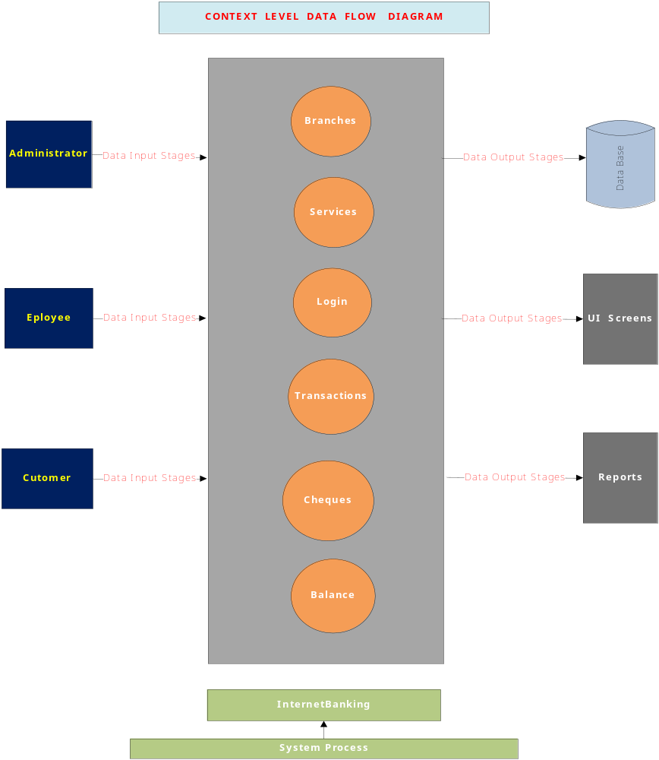

AUTHENTICATION DFD:

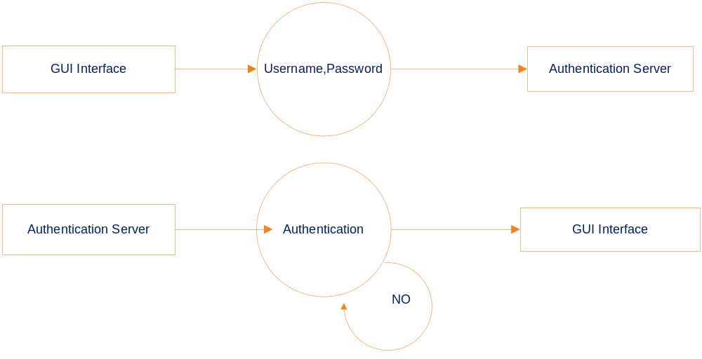
Level 2 Data Flow Diagram for Users Authentication

ADMIN:

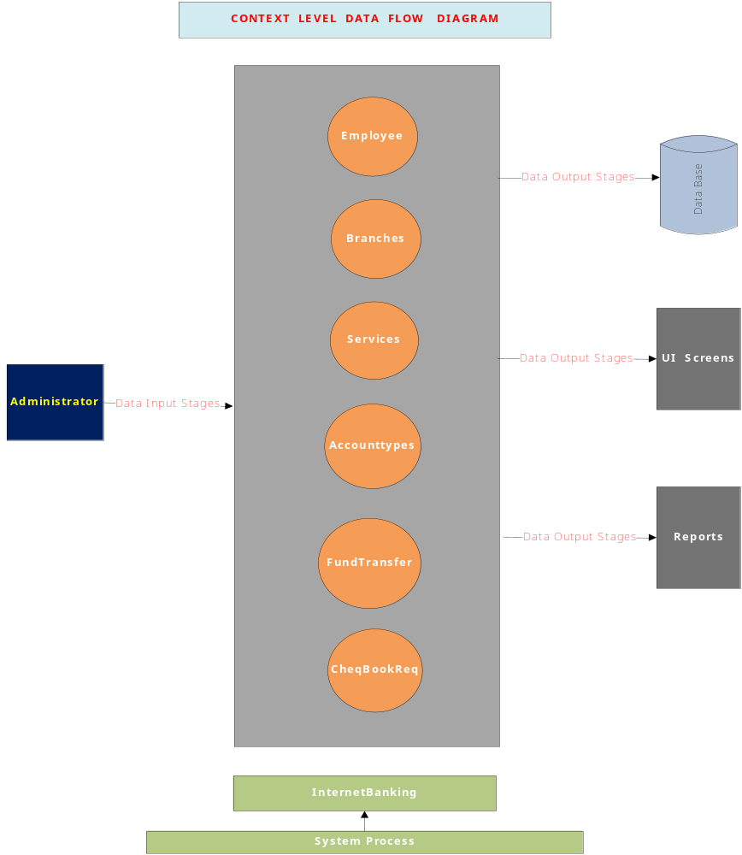

Level1 Data Flow Diagram for Admin:
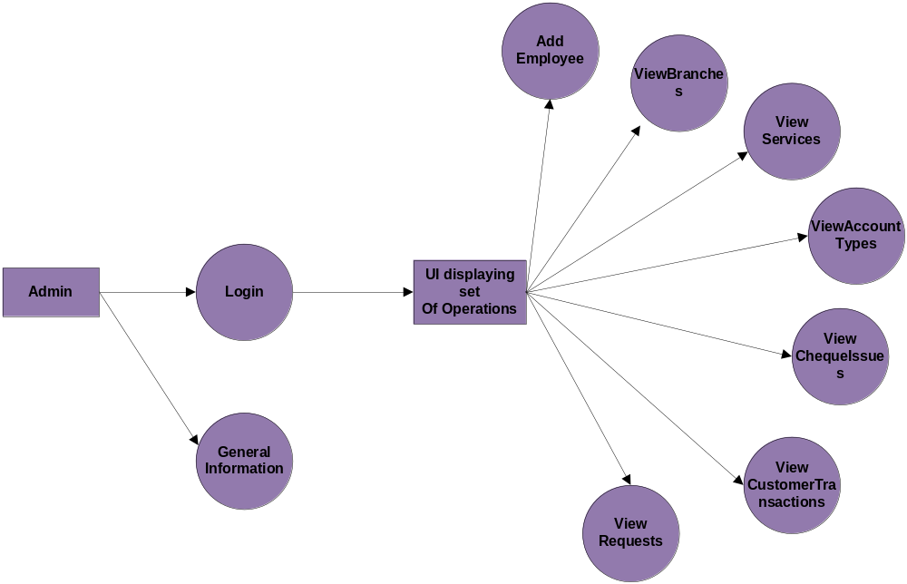
LEVEL-2:
Administrator:
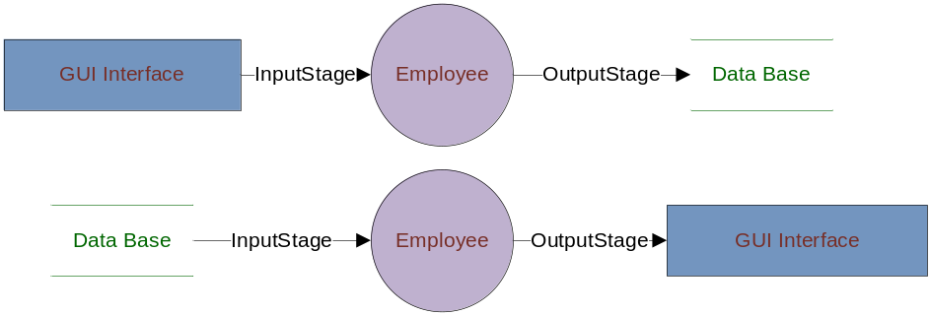

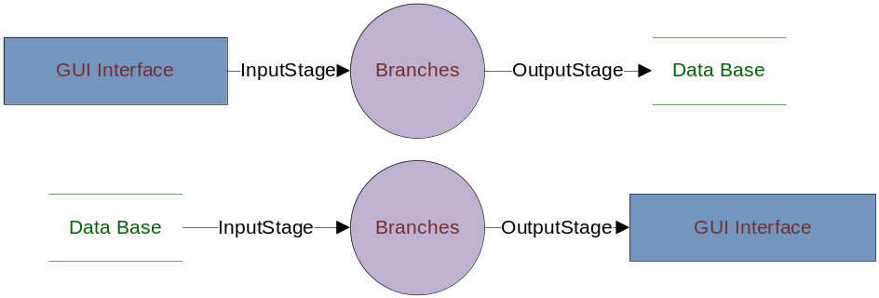

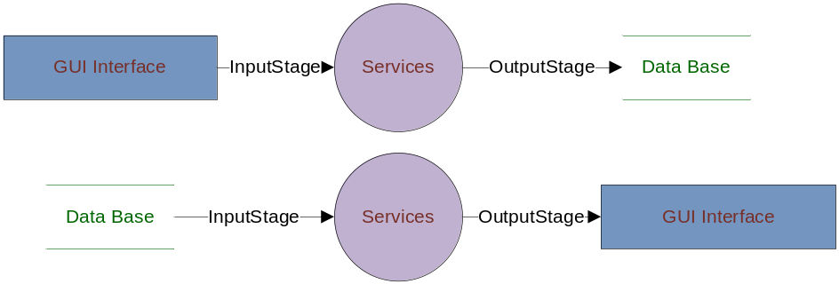

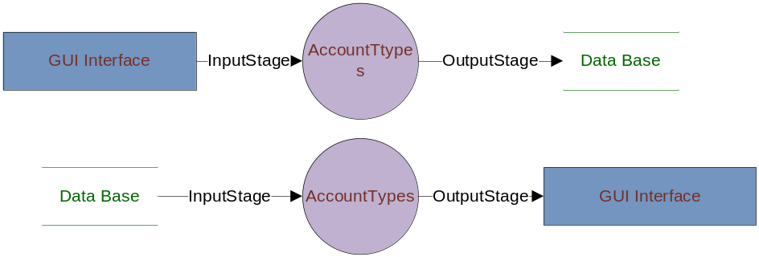

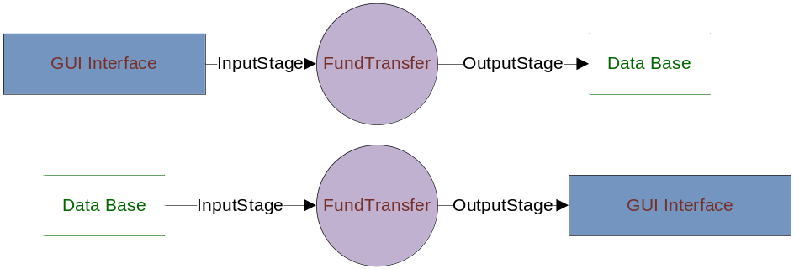

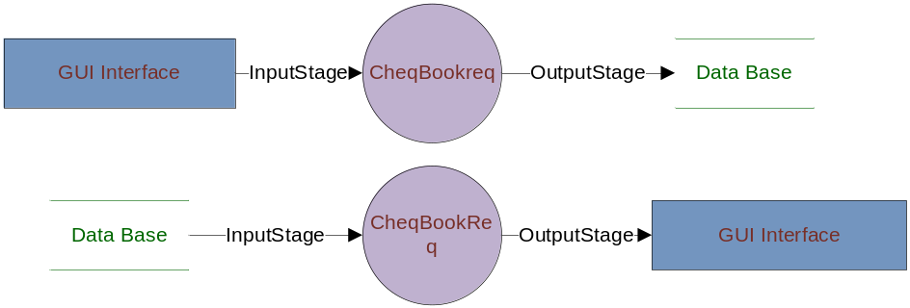

LEVEL-3:
ADMINISTRATOR:
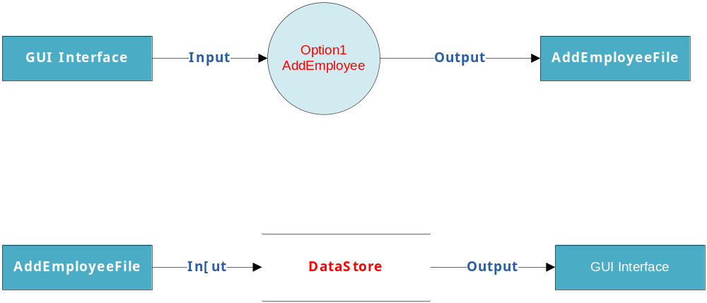

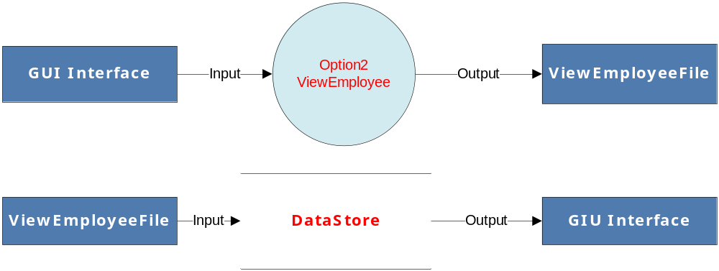

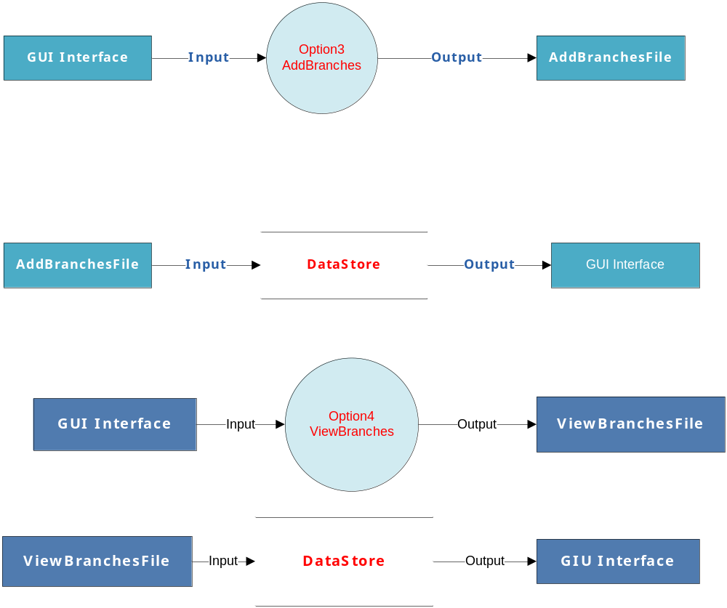

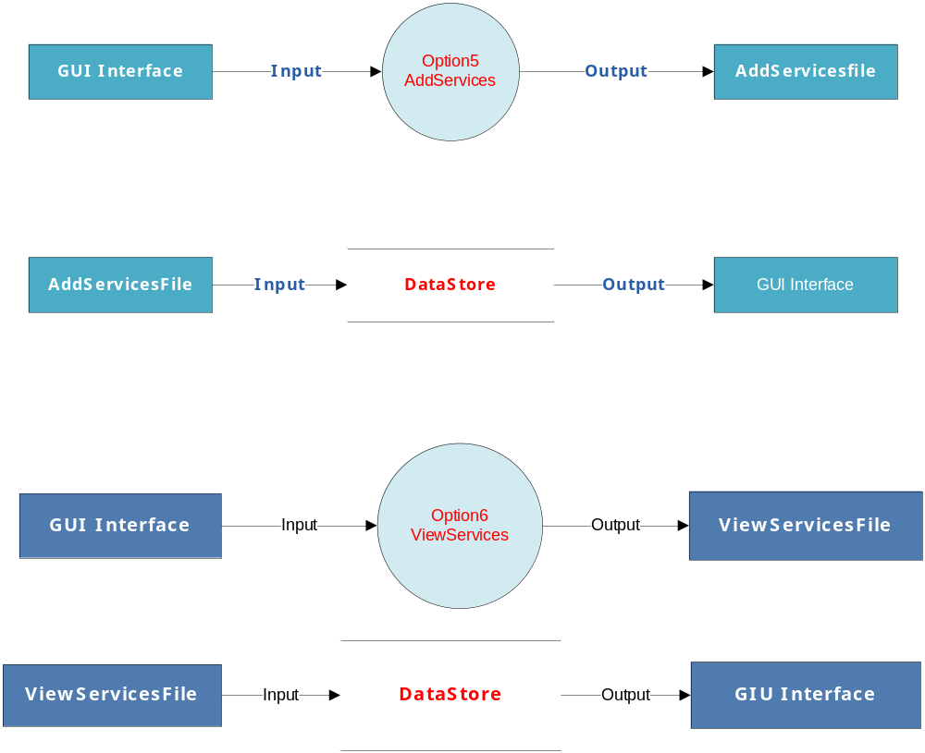

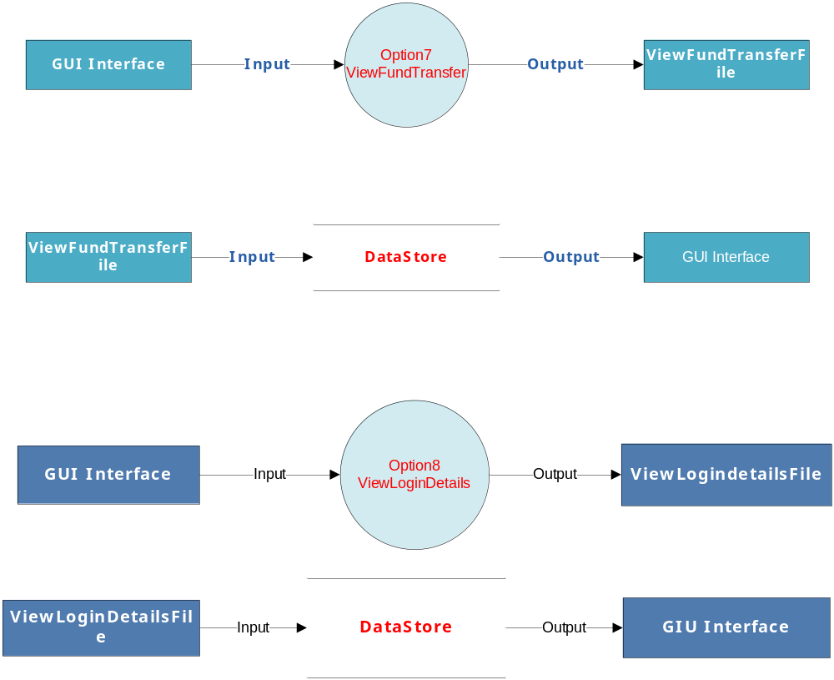

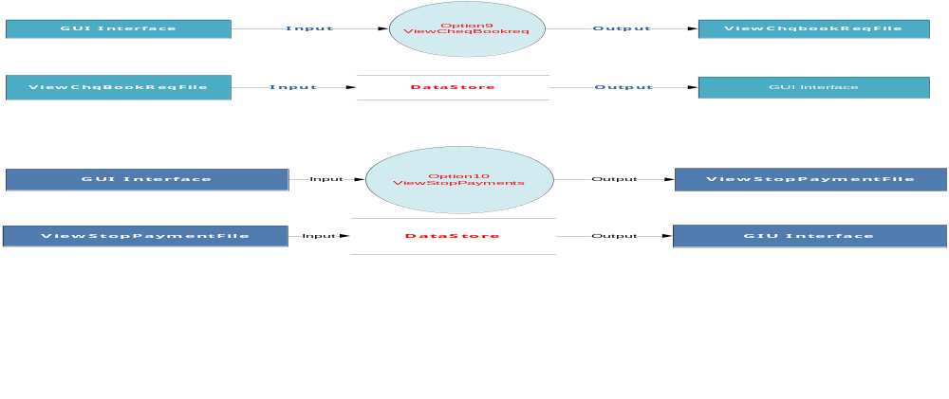

LEVEL-4:
Administrator:

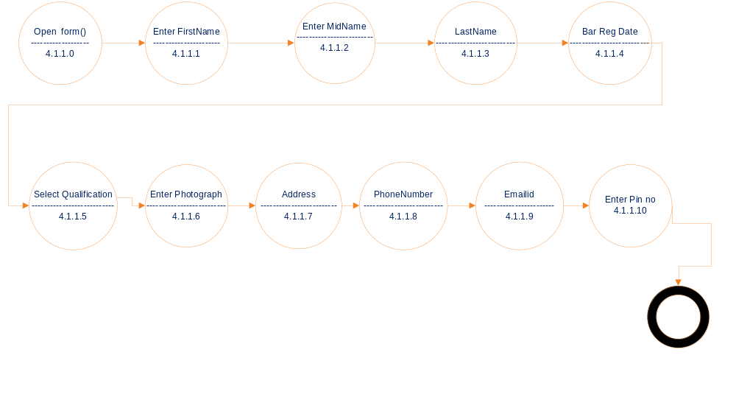
Level 4 Data Flow Diagram for Add Employee Details
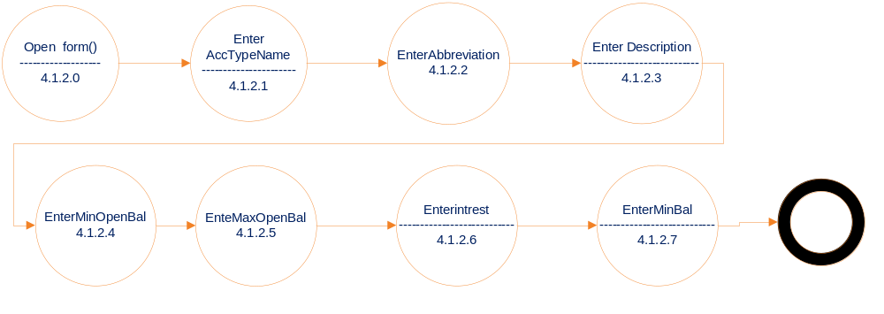 Level 4 Data Flow Diagram for Add Acc Types Details

Employee:
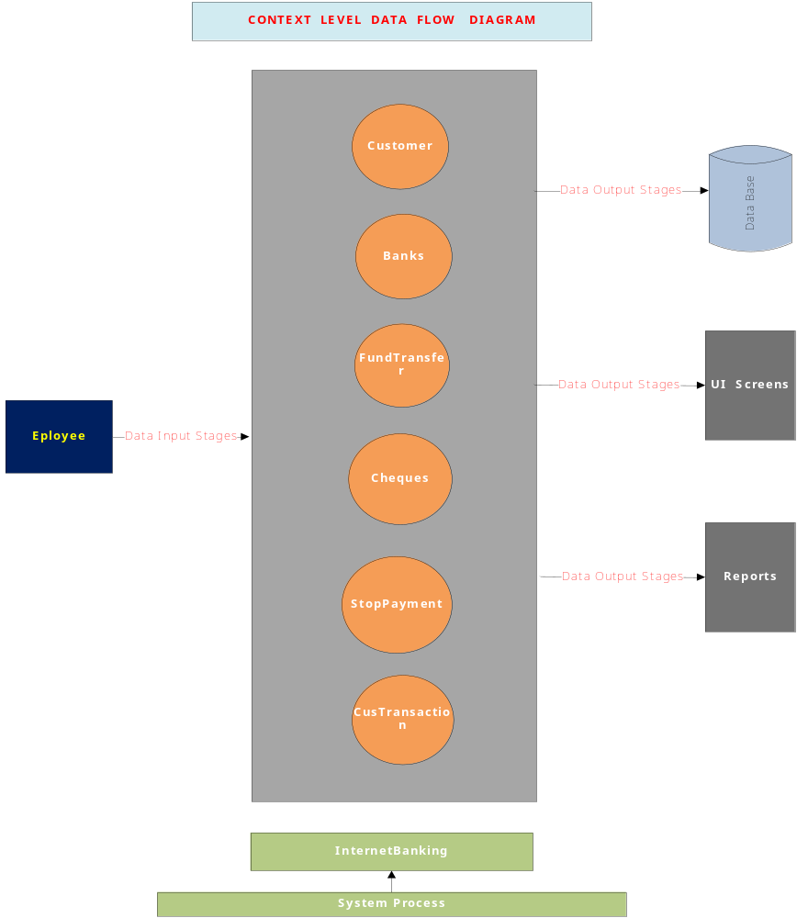

Level1 Data Flow Diagram for Employee:
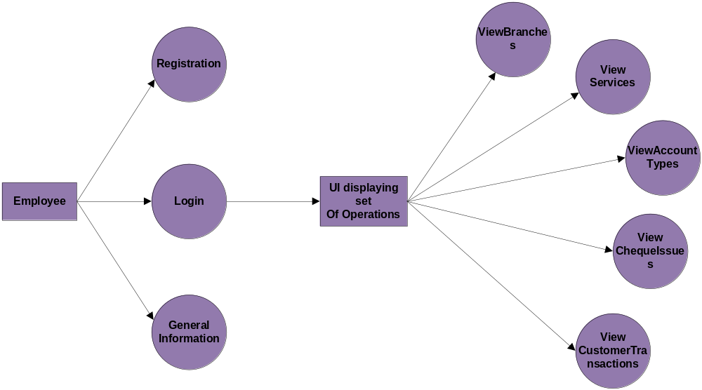
LEVEL-2:
EMPLOYEE:
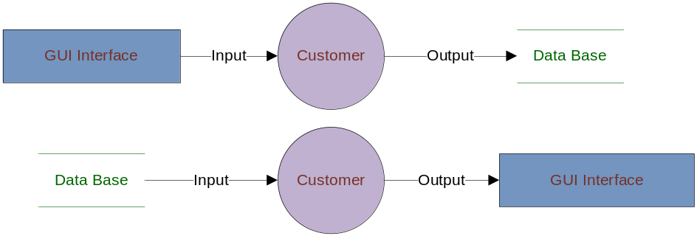

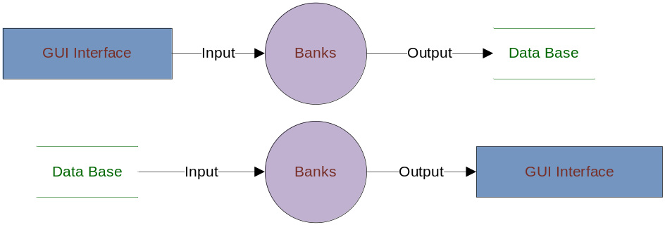

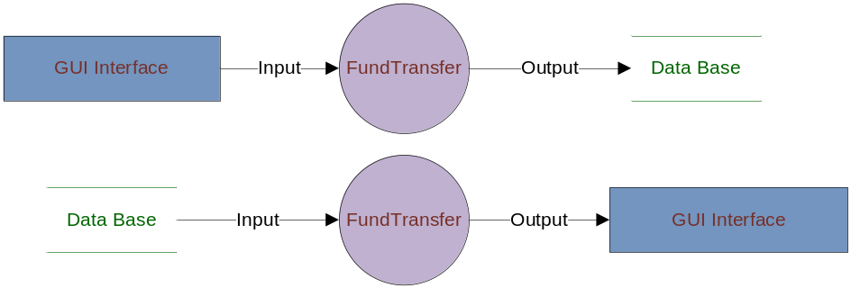

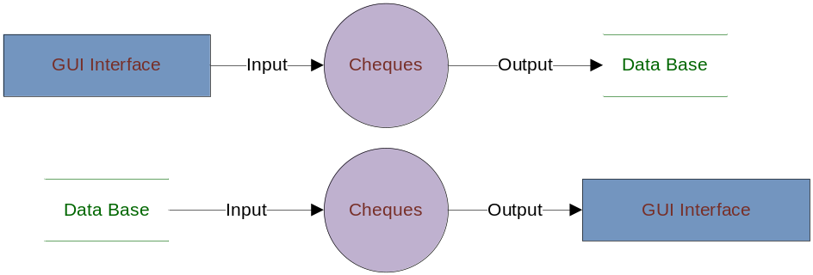

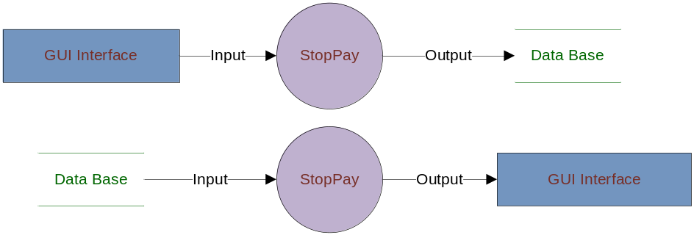

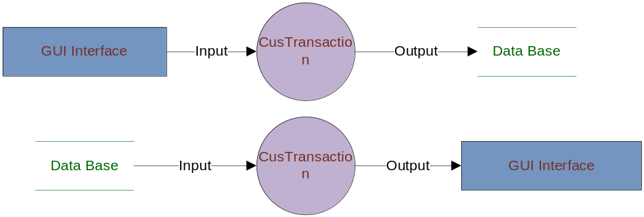
LEVEL-3:
Employee:

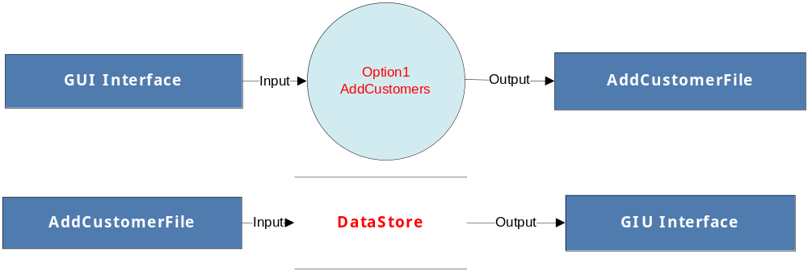

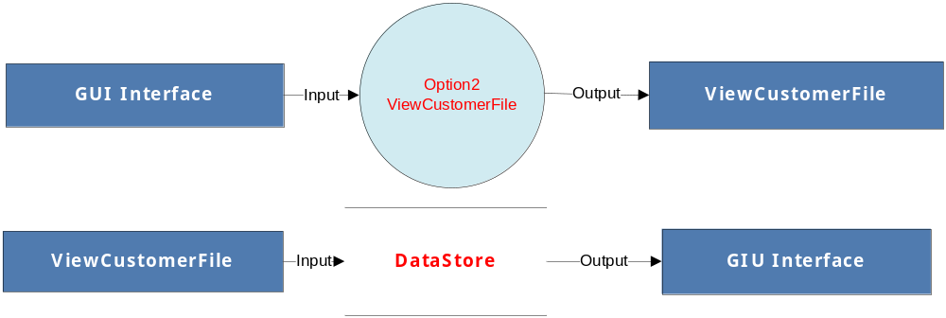

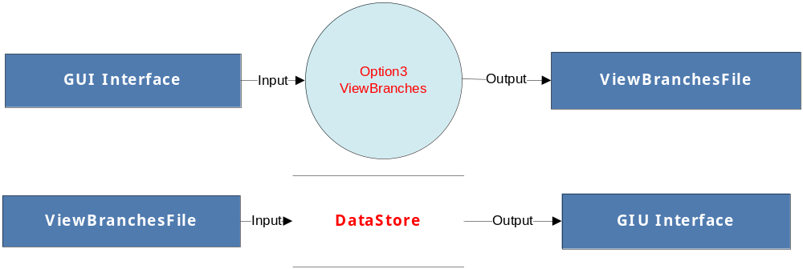

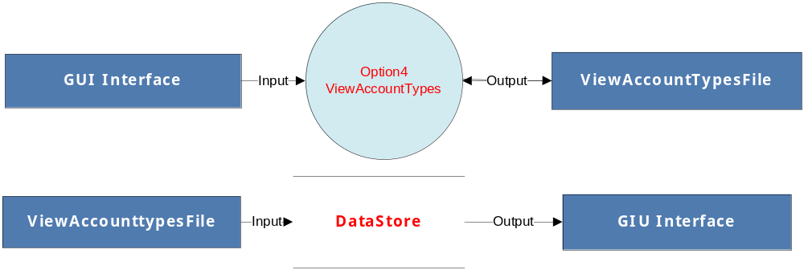

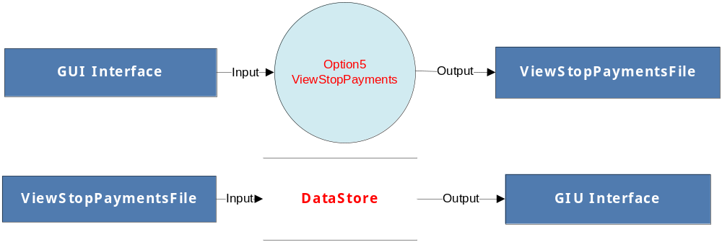

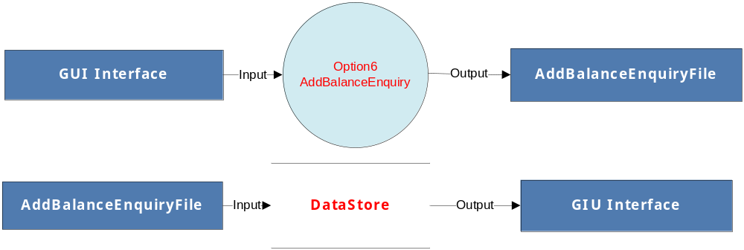

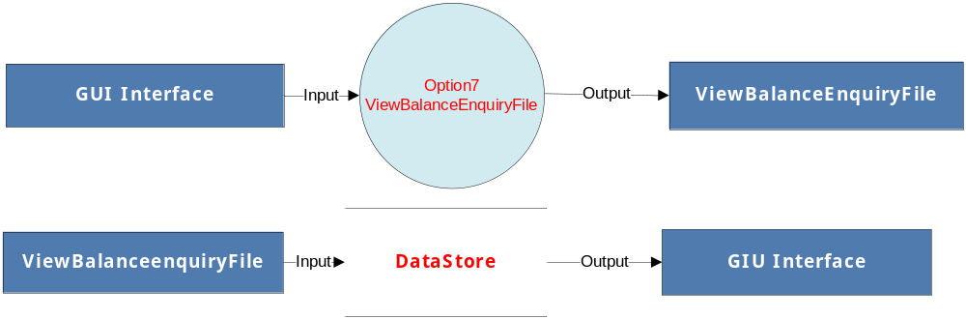

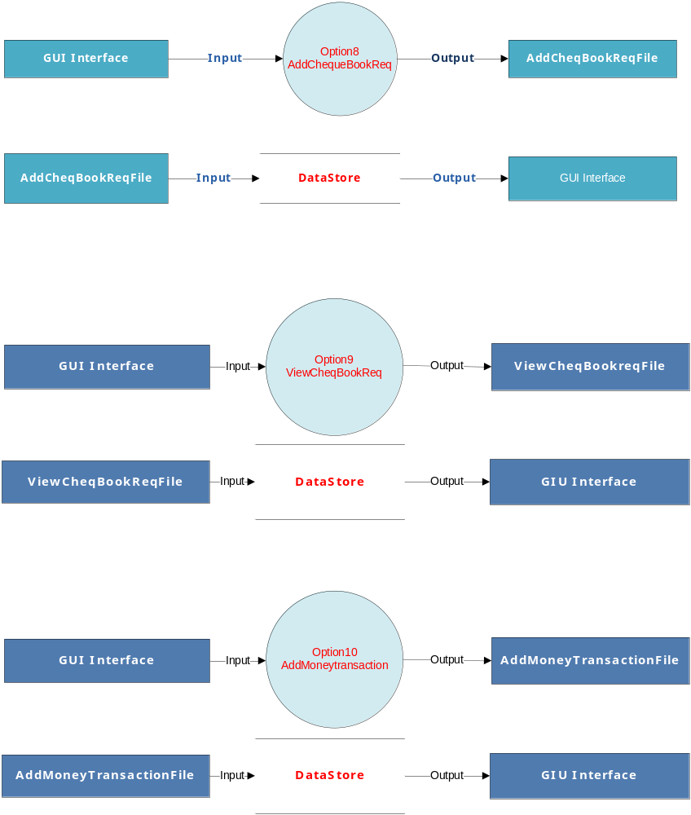
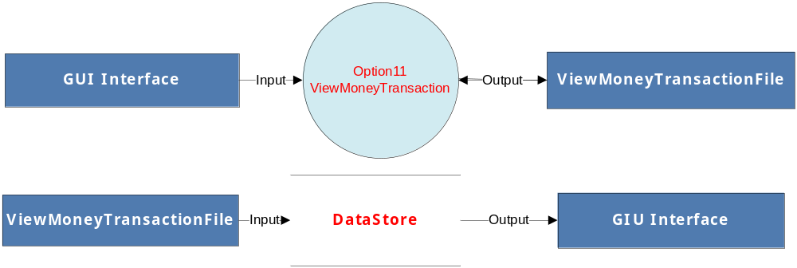

LEVEL-4:
Employee:
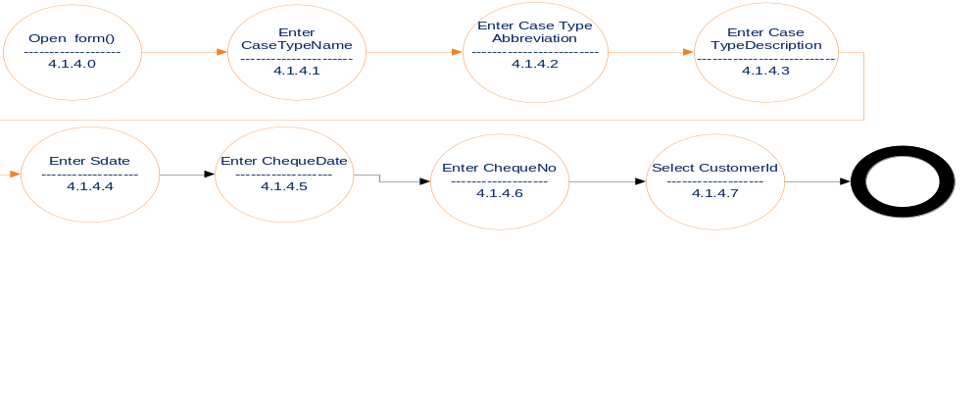

Level 4 Data Flow Diagram for Stop Payment Master Details

LEVEL-0:
Customer: 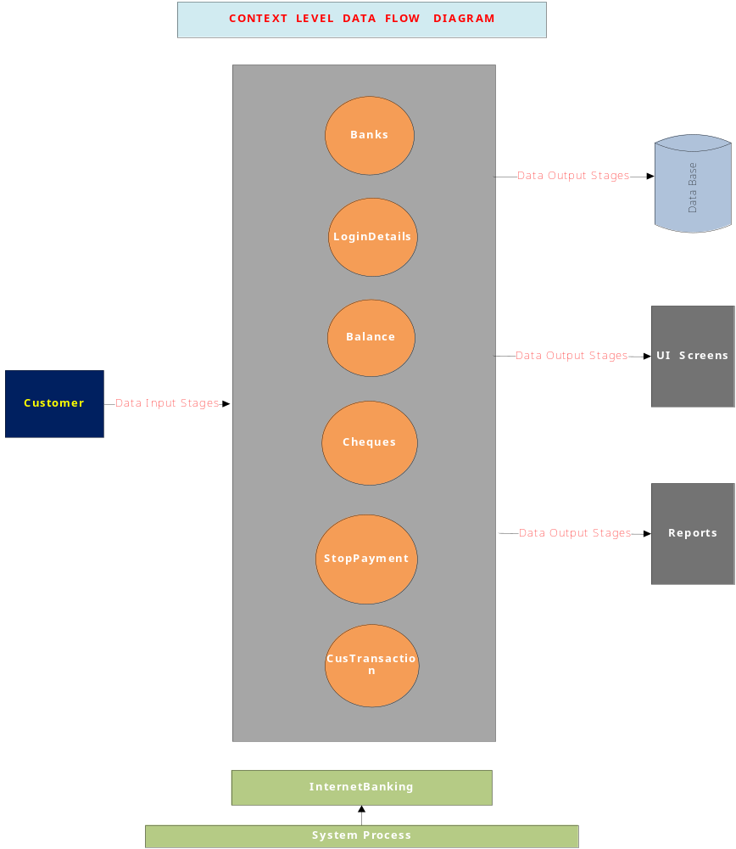

Level1Data Flow Diagram For Customer:

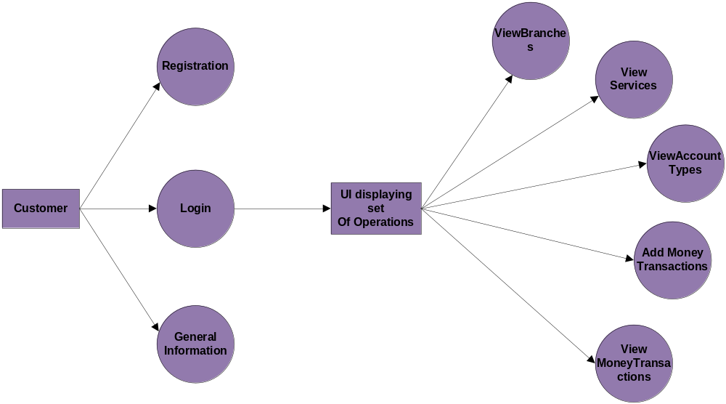

LEVEL-2:
Customer:

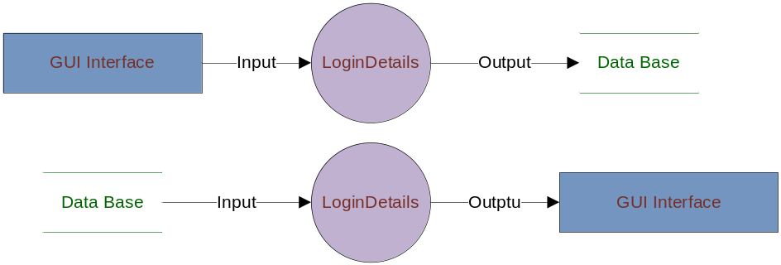

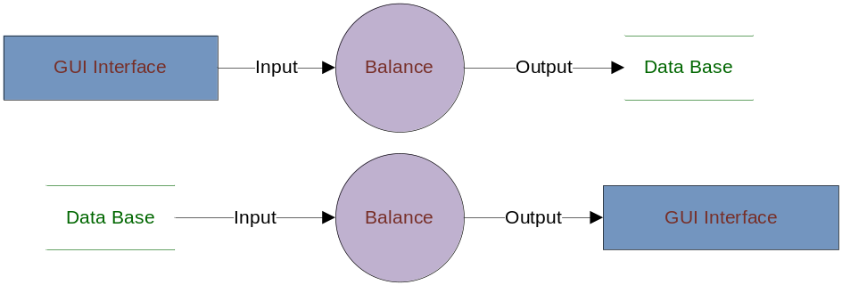

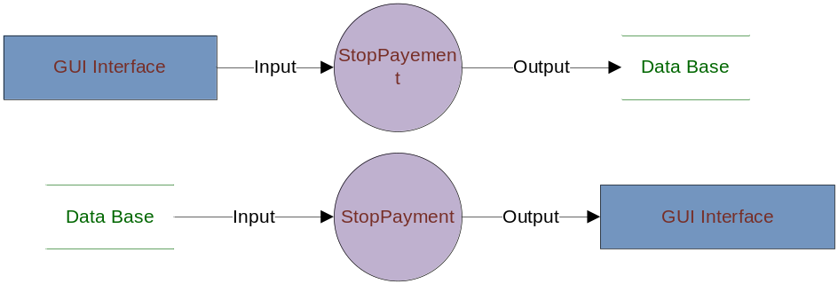

LEVEL-3:
Customer:
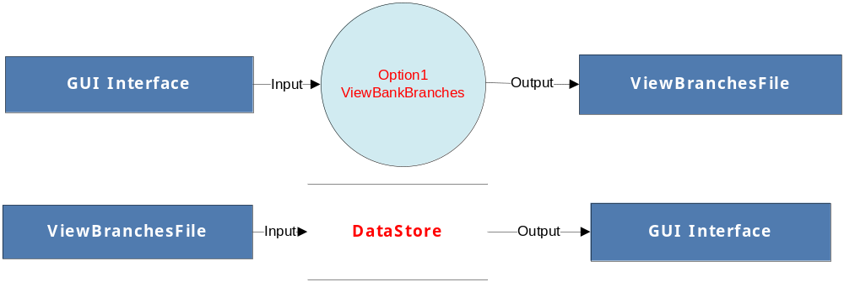

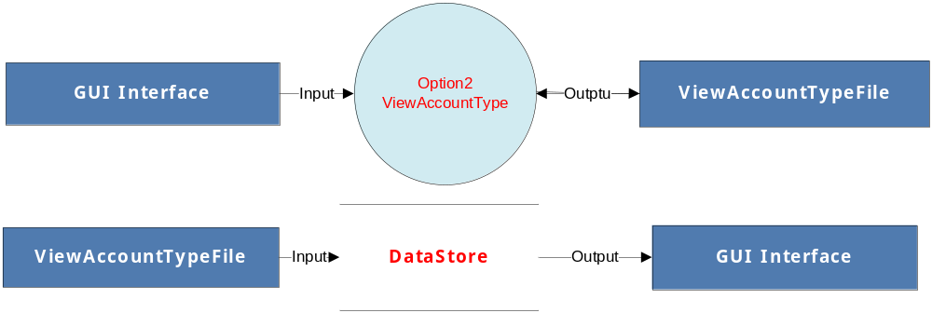

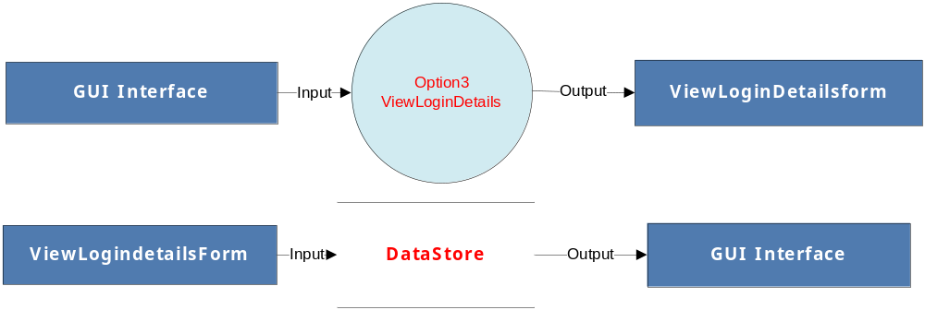
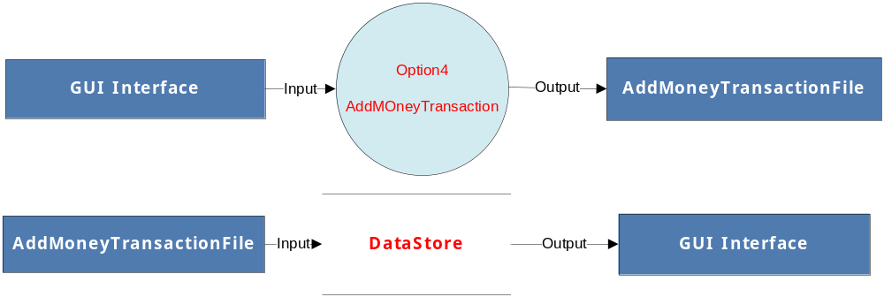

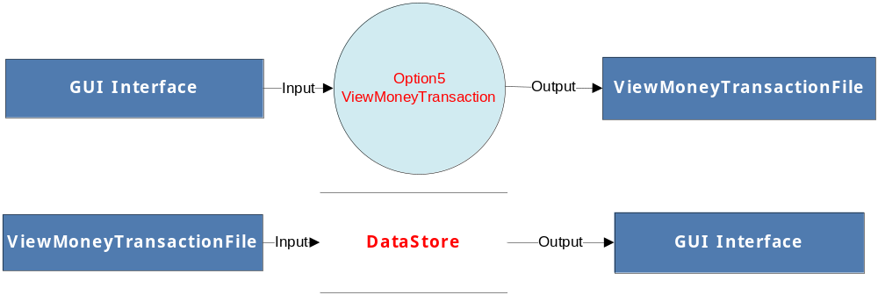

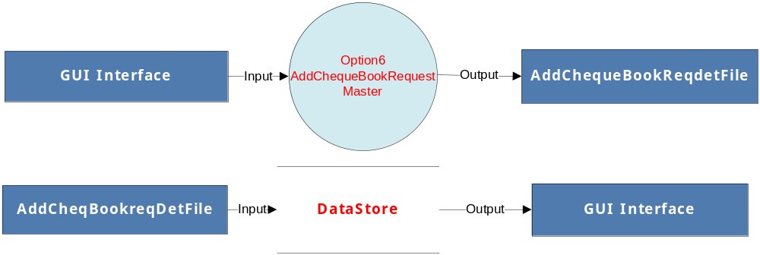

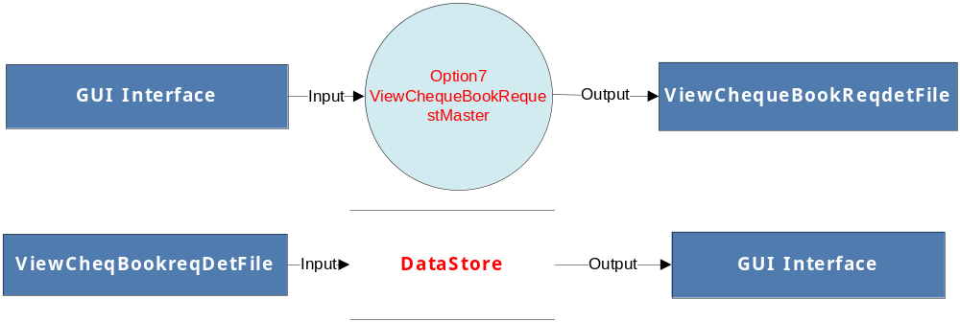

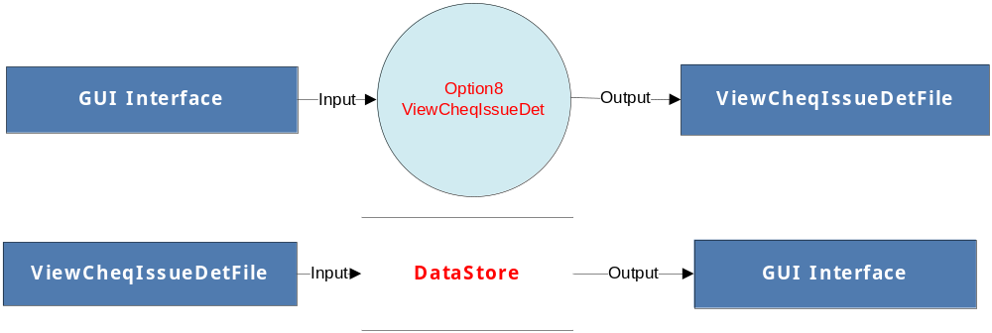

LEVEL-4:
Customer:

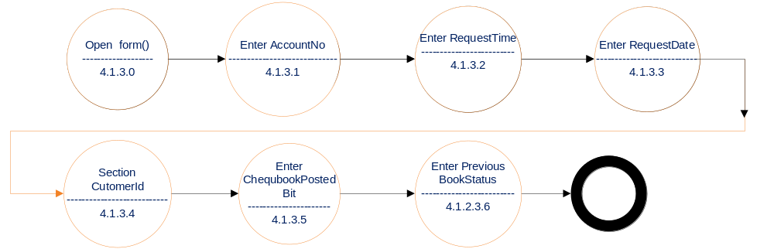
Level 4 Data Flow Diagram for Add Cheque Book Request Details

E-R Diagram

In this the structural and behavioral aspects of the environment in which the system is to be implemented are represented.
UML is specifically constructed through two different domains they are:
  - UML Analysis modeling, this focuses on the user model and structural model views of the system.
  - UML design modeling, which focuses on the behavioral modeling, implementation modeling and environmental model views.

Use case Diagrams represent the functionality of the system from a user’s point of view. Use cases are used during requirements elicitation and analysis to represent the functionality of the system. Use cases focus on the behavior of the system from external point of view.
Actors are external entities that interact with the system. Examples of actors include users like administrator, bank customer …etc., or another system like central database.

Class Collaboration Diagram

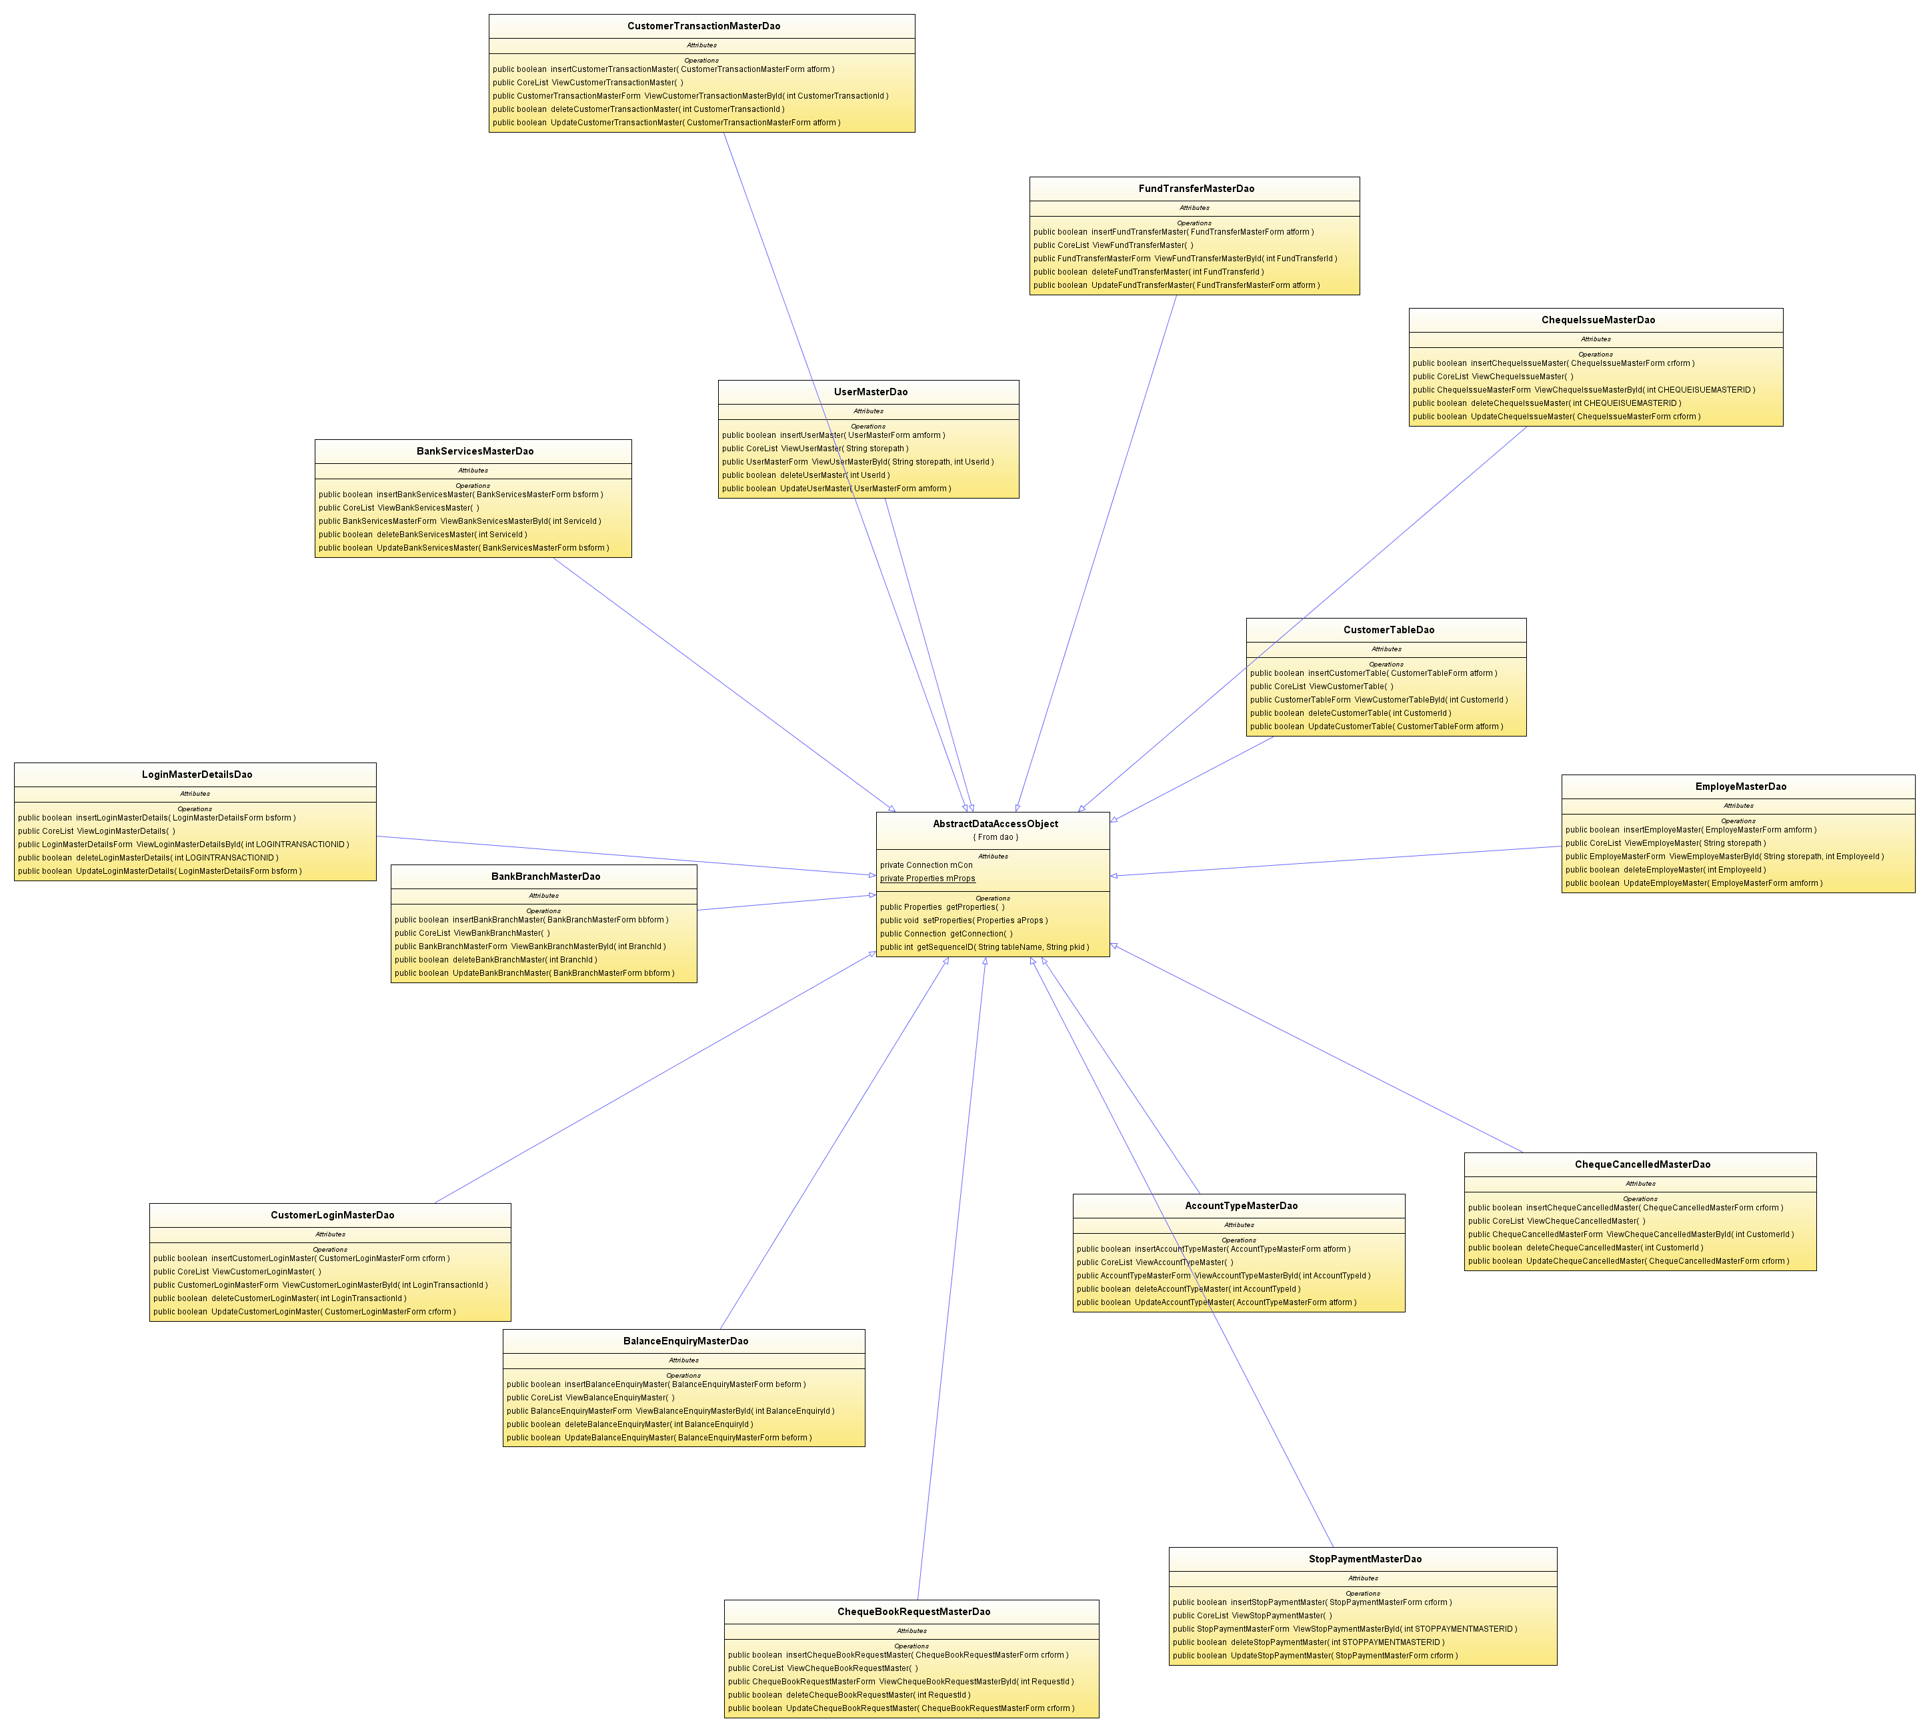

Use Case Diagrams

System use case Diagram:

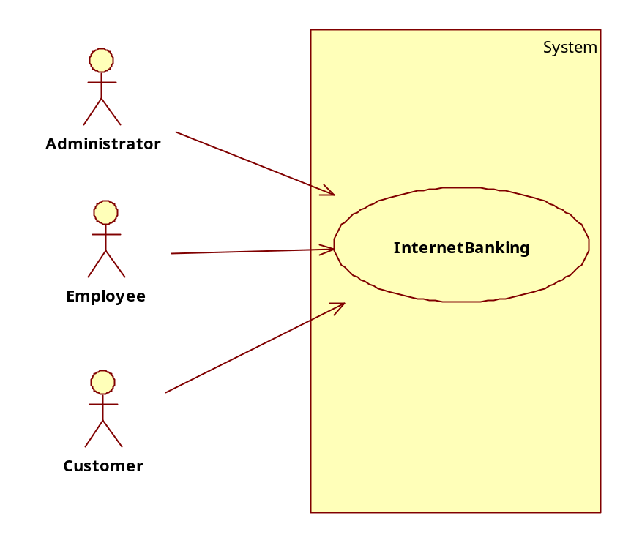

Administrator Use case Diagram:

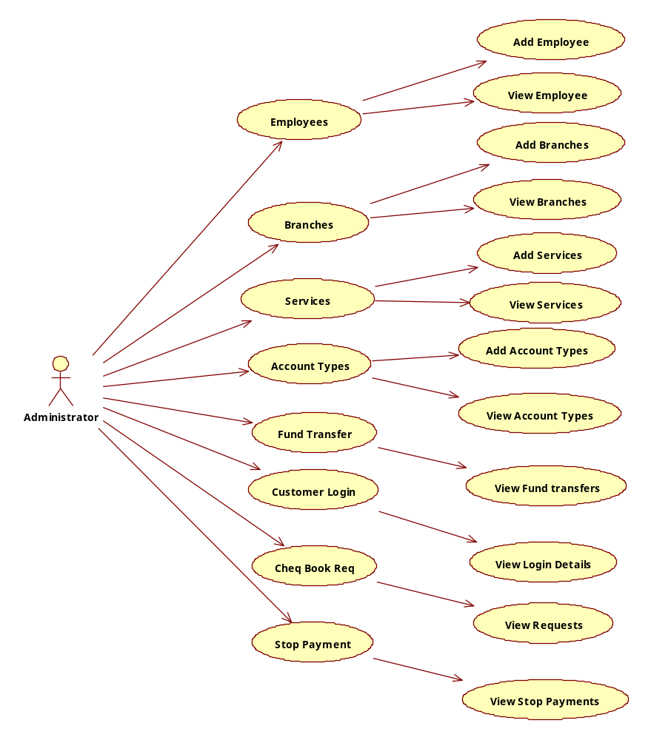

Employee Use case Diagram:
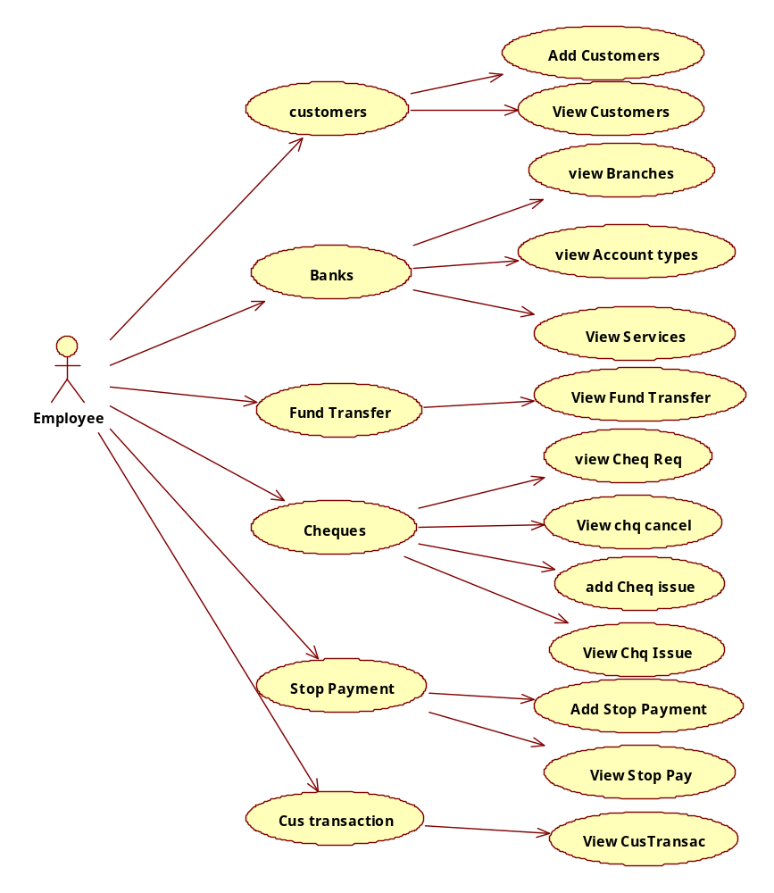

Customer Use Case Diagram:

